Speed life
Antoine L.L.
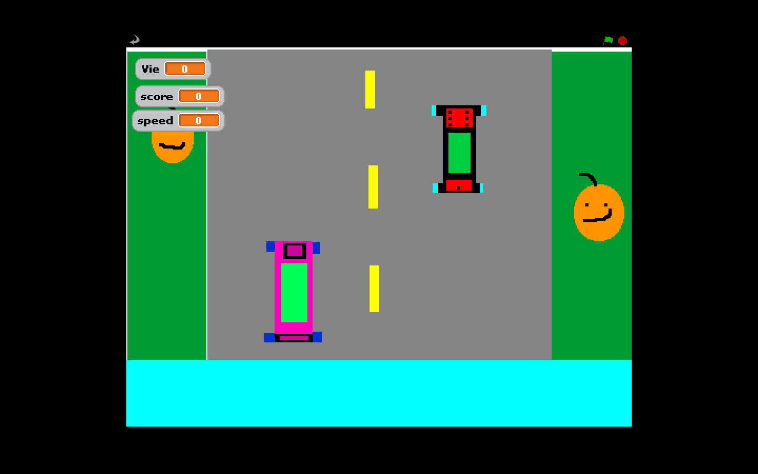
Microsoft tu payes

