La course Mortelle
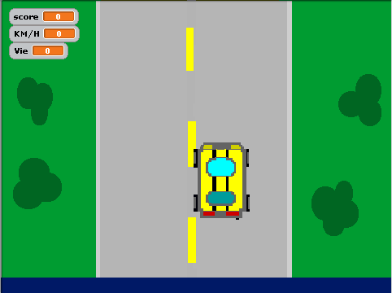
Gabriel Bedard

NO.1

