Cercle
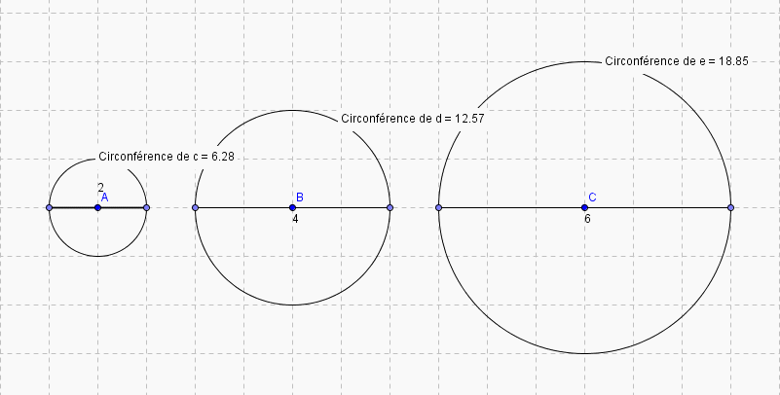
 | C | D | C/D
Cercle 1 | 6.28 | 2 | 3,14
Cercle 2 | 12.57 | 4 | 3,1425
Cercle 3 | 18.85 | 6 | 3,1416

