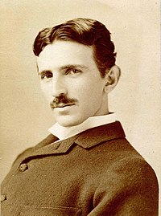
Nikola Tesla
-=-=-=-=-=-=-=-=-=-=-=-=-=-=-=-
Nationality: Austria
-=-=-=-=-=-=-=-=-=-=-=-=-=-=-=-
Date Born/Death: 1856 – 1943
-=-=-=-=-=-=-=-=-=-=-=-=-=-=-=-
Inventions:
Tesla Coil/Tesla Tower/Electric Engine/Electric Generator/Carbon Pellet Lamp/High Frequency Remote/Electric Car/Inspiration For Newer Tesla Cars/And Many More Electrifying Inventions!
-=-=-=-=-=-=-=-=-=-=-=-=-=-=-=-=-=-=-=-=-=-=-=-
Quote: “I don’t care that they stole my idea… I care that they don’t have any of their own.”
-=-=-=-=-=-=-=-=-=-=-=-=-=-=-=-=-=-=-=-=-=-=-=-
F to pay respect.

