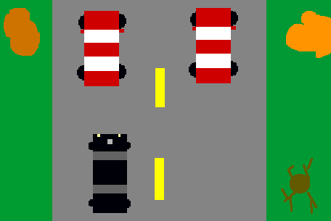
Crach and racing

Microsoft tu paye

Samuel.lachance

