Azerbaïdjan[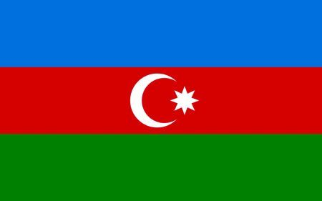](https://www.google.ca/url?sa=i&rct=j&q=&esrc=s&source=images&cd=&ved=&url=https%3A%2F%2Fes.123rf.com%2Fphoto_4428207_ilustraci%25C3%25B3n-bandera-azerbaiy%25C3%25A1n-generado-por-ordenador-.html&psig=AOvVaw3JXe_mvDIAnJY8djw_wbyV&ust=1570211743053564)

[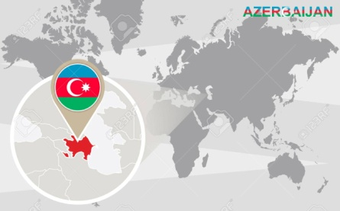](https://www.google.ca/url?sa=i&rct=j&q=&esrc=s&source=images&cd=&cad=rja&uact=8&ved=2ahUKEwiP7dCX1YDlAhVoTt8KHdi2C1cQjRx6BAgBEAQ&url=https%3A%2F%2Ffr.123rf.com%2Fphoto_47649903_carte-du-monde-avec-magnifi%25C3%25A9-l-azerba%25C3%25AFdjan-drapeau-azerba%25C3%25AFdjan-et-la-carte-.html&psig=AOvVaw2Rc38F385tX_9zJTDGteJd&ust=1570211842647900)

[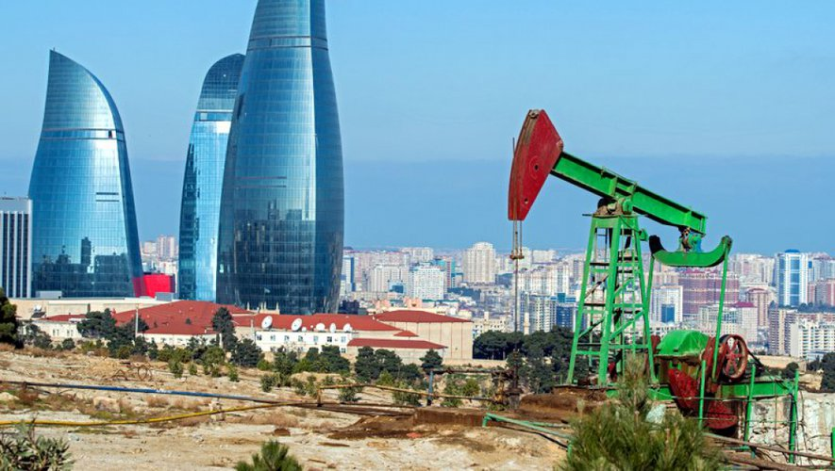](https://www.google.ca/url?sa=i&rct=j&q=&esrc=s&source=images&cd=&ved=2ahUKEwiwr5HN1YDlAhXjlOAKHawVA_EQjRx6BAgBEAQ&url=https%3A%2F%2Fwww.ladepeche.fr%2Farticle%2F2018%2F03%2F30%2F2770417-azerbaidjan-pays-caviar-droits-homme.html&psig=AOvVaw304qOXlRRPXyti0DrrlQbj&ust=1570211981229296)

|  |  |
| --- | --- |
| Pays | Azerbaïdjan |
| Années | Enfant non scolarisé |
| 2012 | 53 736 |
| 2013 | 31 378 |
| 2014 | 25 324 |
| 2015 | 29 661 |
| 2016 | 27 483 |
| 2017 | 34 961 |