Leeuwenhoek

Fait par Anthony et Vincent

[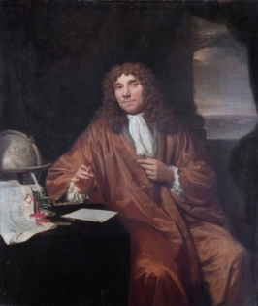](https://www.google.ca/url?sa=i&rct=j&q=&esrc=s&source=images&cd=&ved=2ahUKEwj1h6vMjcnkAhWCl-AKHSpaBqoQjRx6BAgBEAQ&url=https%3A%2F%2Ffr.wikipedia.org%2Fwiki%2FAntoni_van_Leeuwenhoek&psig=AOvVaw16MGprGugpFUCuDy1bLEWH&ust=1568302866904200)Nom au complet : Antoni van Leeuwenhoek

[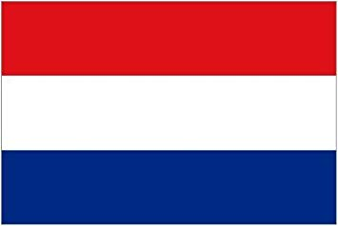](http://www.google.ca/url?sa=i&rct=j&q=&esrc=s&source=images&cd=&cad=rja&uact=8&ved=&url=%2Furl%3Fsa%3Di%26rct%3Dj%26q%3D%26esrc%3Ds%26source%3Dimages%26cd%3D%26ved%3D%26url%3Dhttps%253A%252F%252Fwww.amazon.fr%252FThe-Specialist-Flag-Shop-HOLLANDAIS%252Fdp%252FB00GO27LIC%26psig%3DAOvVaw0SyoHch-R0x83ClSUkEHo6%26ust%3D1568303066435886&psig=AOvVaw0SyoHch-R0x83ClSUkEHo6&ust=1568303066435886)image de lui :

nationalité + drapeau : Néerlandais

[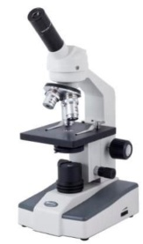](http://www.google.ca/url?sa=i&rct=j&q=&esrc=s&source=images&cd=&ved=2ahUKEwjGqfe3j8nkAhVmS98KHdDEBtoQjRx6BAgBEAQ&url=http%3A%2F%2Fblog.ac-versailles.fr%2Ftruffautsvt%2Fpublic%2FGRAIN_Utiliser_un_microscope%2Findex.html&psig=AOvVaw3_y3YulAIrSzhuFIt8KwxB&ust=1568303356784122)période de temps : 1632 à 1723

[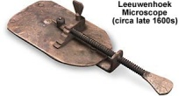](http://www.google.ca/url?sa=i&rct=j&q=&esrc=s&source=images&cd=&cad=rja&uact=8&ved=2ahUKEwivm6-Xj8nkAhWGnFkKHdDcD9MQjRx6BAgBEAQ&url=%2Furl%3Fsa%3Di%26rct%3Dj%26q%3D%26esrc%3Ds%26source%3Dimages%26cd%3D%26ved%3D2ahUKEwiFltiWj8nkAhUl11kKHTucB4wQjRx6BAgBEAQ%26url%3Dhttps%253A%252F%252Fmicro.magnet.fsu.edu%252Fprimer%252Fmuseum%252Fleeuwenhoek.html%26psig%3DAOvVaw2amYUXWNyk75BAiQDtNTeV%26ust%3D1568303279871729&psig=AOvVaw2amYUXWNyk75BAiQDtNTeV&ust=1568303279871729)découverte : Microscope

image de sa découverte :