Bélarus

[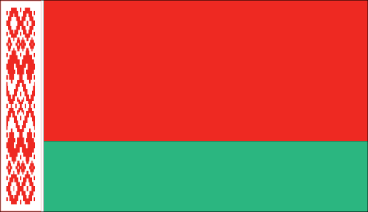](https://www.google.com/url?sa=i&rct=j&q=&esrc=s&source=images&cd=&ved=2ahUKEwjjuZmu1YDlAhVKTt8KHYHgB68QjRx6BAgBEAQ&url=https%3A%2F%2Flesplusbeauxdrapeauxdumonde.com%2F2016%2F11%2F14%2Fle-drapeau-du-belarus%2F&psig=AOvVaw0xwPJR2jvTfz92WuIic-AO&ust=1570211916525838)

Drapeau :

[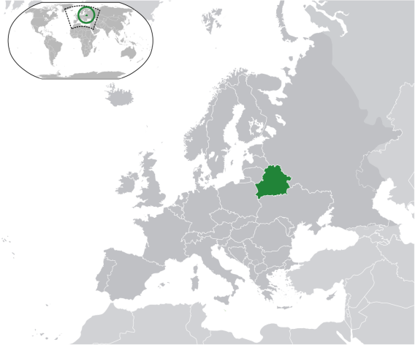](https://www.google.com/url?sa=i&rct=j&q=&esrc=s&source=images&cd=&ved=2ahUKEwjm-6zB1YDlAhVDw1kKHTyYAsAQjRx6BAgBEAQ&url=https%3A%2F%2Ffr.wikipedia.org%2Fwiki%2FBi%25C3%25A9lorussie&psig=AOvVaw2FbFAPyVGUDPhJjvgOWWTo&ust=1570211955470564)

Carte du monde :

[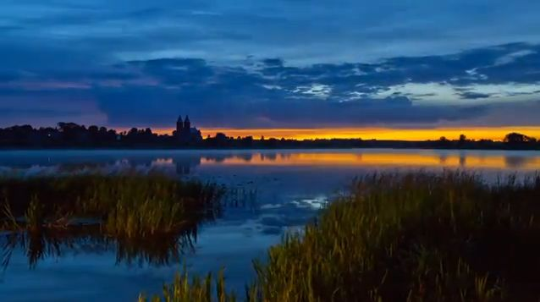](https://www.google.com/url?sa=i&rct=j&q=&esrc=s&source=images&cd=&ved=2ahUKEwi-nfLx1YDlAhXyNX0KHeeqB9wQjRx6BAgBEAQ&url=https%3A%2F%2Finterviewsculture.wordpress.com%2F2013%2F01%2F25%2Fles-paysages-bielorusses-en-vue-spatiale%2F&psig=AOvVaw316Em7xOD4fridU-AHa9hw&ust=1570212022691165)

Le paysage :

|  |  |
| --- | --- |
| pays | Bélarus |
| Années | enfant non scolarisé |
| 2012 | 20276 |
| 2013 | 24701 |
| 2014 | 28646 |
| 2015 | 20855 |
| 2016 | 14400 |
| 2017 | 16598 |