[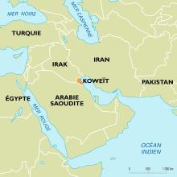](https://www.google.ca/url?sa=i&rct=j&q=&esrc=s&source=images&cd=&ved=2ahUKEwjBpf2h1oDlAhXPg-AKHb0FAYMQjRx6BAgBEAQ&url=https%3A%2F%2Fwww.universalis.fr%2Fatlas%2Fasie%2Fmoyen-orient%2Fkoweit%2F&psig=AOvVaw1hJcUVfwOqWRX3aGeDtQBP&ust=1570212154627670)KOWEïT

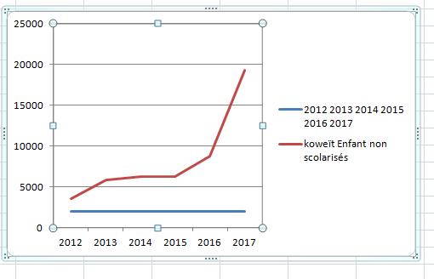[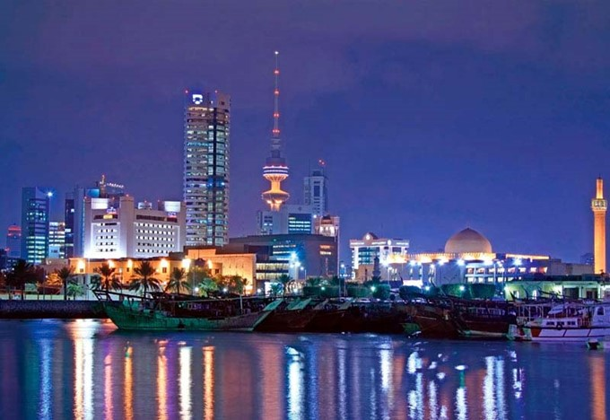](http://www.google.ca/url?sa=i&rct=j&q=&esrc=s&source=images&cd=&cad=rja&uact=8&ved=2ahUKEwi7jKWN1oDlAhWoV98KHZzTA-kQjRx6BAgBEAQ&url=http%3A%2F%2Fwww.orangesmile.com%2Fguide-touristique%2Fkoweit-kw%2Findex.htm&psig=AOvVaw1jeHVogaDeK_MkfZVgqlbR&ust=1570211980025285)[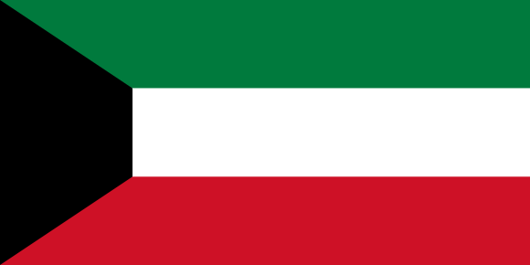](https://www.google.ca/url?sa=i&rct=j&q=&esrc=s&source=images&cd=&ved=2ahUKEwjqr4-41YDlAhUkneAKHXUzC-8QjRx6BAgBEAQ&url=https%3A%2F%2Fwww.drapeauxdespays.fr%2Fkoweit&psig=AOvVaw2s95_JahKVAozUrvXnya5s&ust=1570211905839599)

|  |  |  |
| --- | --- | --- |
| pays | Koweït |  |
| année | Enfant non scolarisés |  |
| 2012 | 3575 |  |
| 2013 | 5843 |  |
| 2014 | 6218 |  |
| 2015 | 6218 |  |
| 2016 | 8799 |  |
| 2017 | 19258 |  |