[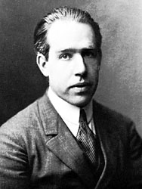](https://www.google.ca/url?sa=i&rct=j&q=&esrc=s&source=images&cd=&ved=2ahUKEwjVm-bd7s7lAhVElVkKHc7PChMQjRx6BAgBEAQ&url=https://www.britannica.com/biography/Niels-Bohr&psig=AOvVaw2Fxdcy8hL-GbCXUkuGolHH&ust=1572898783575791)Bohr

[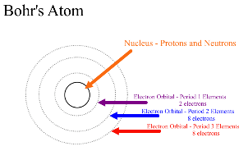](https://www.google.ca/url?sa=i&rct=j&q=&esrc=s&source=images&cd=&ved=2ahUKEwit6rKo787lAhURvVkKHVIjCZ0QjRx6BAgBEAQ&url=https://socratic.org/questions/how-many-electrons-go-on-each-ring-according-to-the-bohr-model&psig=AOvVaw0SP8n4svEEHdRqetMb3YqD&ust=1572898924067642)Nom au complet : Niels Henrik David Bohr

Découverte : orbitales

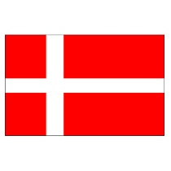Nationalité : Danemark

Période de temps : 1885-1962