[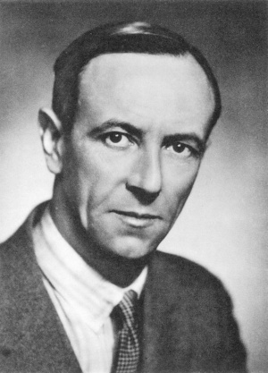](https://www.google.ca/url?sa=i&rct=j&q=&esrc=s&source=images&cd=&ved=&url=https%3A%2F%2Fwww.britannica.com%2Fbiography%2FJames-Chadwick&psig=AOvVaw1UwPUFYutSKvpuVzOwQHni&ust=1573314700519396)Chadwick

[](http://www.google.ca/url?sa=i&rct=j&q=&esrc=s&source=images&cd=&cad=rja&uact=8&ved=&url=%2Furl%3Fsa%3Di%26rct%3Dj%26q%3D%26esrc%3Ds%26source%3Dimages%26cd%3D%26ved%3D%26url%3Dhttps%253A%252F%252Fwww.amazon.fr%252FPlanete-Supporter-Drapeau-Angleterre-150%252Fdp%252FB00CO5Z8L0%26psig%3DAOvVaw1yeNSGVJfmq7I1mVKw3Gh6%26ust%3D1573314667341886&psig=AOvVaw1yeNSGVJfmq7I1mVKw3Gh6&ust=1573314667341886)Nom au complet : James Chadwick

Nationalité : Anglais

[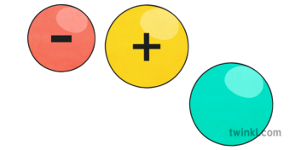](https://www.google.ca/url?sa=i&rct=j&q=&esrc=s&source=images&cd=&ved=&url=https%3A%2F%2Fwww.twinkl.ca%2Fillustration%2Fproton-neutron-electron&psig=AOvVaw1gKDU8xTFc1ZqVGG9f-mNq&ust=1573314589661259)Période de temps : 1891 à 1974

Découverte : Neutron