[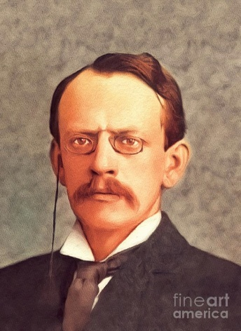](https://pixels.com/featured/j-j-thomson-famous-scientist-john-springfield.html)Thomson

Fait par : Enrick Lessard

Joseph John Thomson

[](http://www.google.ca/url?sa=i&rct=j&q=&esrc=s&source=images&cd=&cad=rja&uact=8&ved=2ahUKEwiFwM_licflAhVxTt8KHUvaCXoQjRx6BAgBEAQ&url=%2Furl%3Fsa%3Di%26rct%3Dj%26q%3D%26esrc%3Ds%26source%3Dimages%26cd%3D%26ved%3D2ahUKEwjonfTkicflAhXo1FkKHQnkCDoQjRx6BAgBEAQ%26url%3Dhttps%253A%252F%252Fwww.amazon.fr%252FPlanete-Supporter-Drapeau-Angleterre-150%252Fdp%252FB00CO5Z8L0%26psig%3DAOvVaw33peg3BmnvoQzzmnemNNov%26ust%3D1572631169929976&psig=AOvVaw33peg3BmnvoQzzmnemNNov&ust=1572631169929976)Découverte : Charge Atomique

[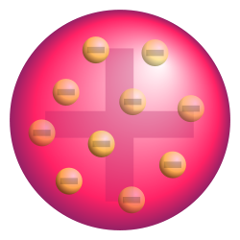](http://www.google.ca/url?sa=i&rct=j&q=&esrc=s&source=images&cd=&cad=rja&uact=8&ved=2ahUKEwjcxvnGicflAhXimuAKHYQVCn0QjRx6BAgBEAQ&url=%2Furl%3Fsa%3Di%26rct%3Dj%26q%3D%26esrc%3Ds%26source%3Dimages%26cd%3D%26ved%3D%26url%3Dhttps%253A%252F%252Ffr.wikipedia.org%252Fwiki%252FMod%2525C3%2525A8le_atomique_de_Thomson%26psig%3DAOvVaw2KKzXMiZfz67UMD2_-Q1qc%26ust%3D1572631099638040&psig=AOvVaw2KKzXMiZfz67UMD2_-Q1qc&ust=1572631099638040)Nationalité : Angleterre

Période de Temps : 1856-1940