[](http://www.enjoy-study-usa.com/)[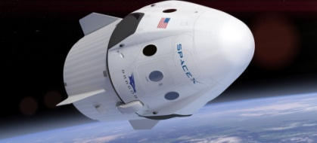](https://www.google.ca/url?sa=i&rct=j&q=&esrc=s&source=images&cd=&cad=rja&uact=8&ved=2ahUKEwjOxNHGrLrmAhUEZN8KHRIoBm0QjRx6BAgBEAQ&url=https%3A%2F%2Fwww.universetoday.com%2F132330%2Felon-musk-announces-daring-spacex-dragon-flight-beyond-the-moon-with-2-private-astronauts-in-2018%2F&psig=AOvVaw1adQ8QKSMN7TGqtjC0p1QP&ust=1576591867500195)spaceXdragon

Quoi fusée

[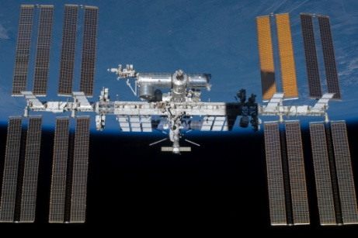](https://www.google.ca/url?sa=i&rct=j&q=&esrc=s&source=images&cd=&ved=2ahUKEwiSzrOBrrrmAhWvd98KHV6sCGMQjRx6BAgBEAQ&url=https%3A%2F%2Fwww.nasa.gov%2Fmission_pages%2Fstation%2Fmain%2Findex.html&psig=AOvVaw2cbLC5HhWQ20cajFWy0bTI&ust=1576592260515333)[](https://icon-library.net/icon/x-icon-9.html)A qui usa

Pourquoi 🡺ISS NAVETTE

[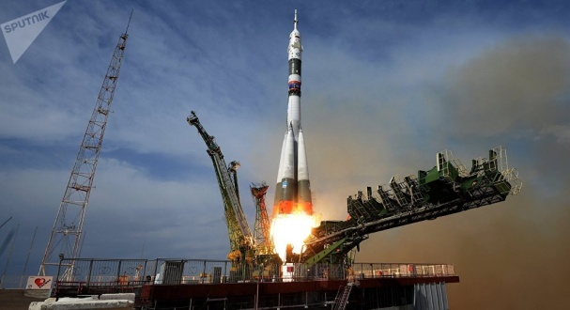](https://www.google.ca/url?sa=i&rct=j&q=&esrc=s&source=images&cd=&ved=2ahUKEwjYtuWZrrrmAhWuneAKHeNnCuEQjRx6BAgBEAQ&url=https%3A%2F%2Ffr.sputniknews.com%2Fsci_tech%2F201806071036696588-video-separation-vaisseau-spatial-lanceur%2F&psig=AOvVaw1xmYPaQ9_ZCGku7qWUa-o_&ust=1576592313744459)SINON SOYOUZ