[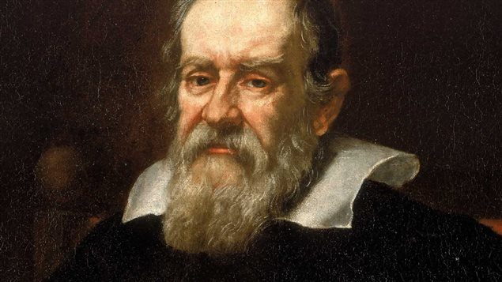](https://www.google.com/url?sa=i&url=http%3A%2F%2Fici.radio-canada.ca%2Femissions%2Fa_rebours%2F2013-2014%2Fchronique.asp%3FidChronique%3D348762&psig=AOvVaw24EPi330aOYEJnX4qBE8W6&ust=1622562207014000&source=images&cd=vfe&ved=0CAIQjRxqFwoTCNippbGh9PACFQAAAAAdAAAAABAD)Galilé

Nom au complet :Galileo Galilé

[](https://www.google.ca/url?sa=i&url=https%3A%2F%2Ffr.wikipedia.org%2Fwiki%2FDrapeau_de_l%2527Italie&psig=AOvVaw3mHsZkU0ReVog9ARe9CY1P&ust=1622562383838000&source=images&cd=vfe&ved=0CAIQjRxqFwoTCIj_q4Wi9PACFQAAAAAdAAAAABAD)Nationalité : Italien

Période de temps :1564-1642

Decouverte : [Ganymède](https://www.google.com/search?safe=strict&bih=731&biw=1440&hl=fr&q=Ganym%C3%A8de+(lune)&stick=H4sIAAAAAAAAAOPgE-LQz9U3MDbJLlYCs9JMLZK1lLOTrfQTi0uK8vPycyvhrNQiq5TM4uT8stSi1JRFrALuiXmVuYdXpKQqaOSU5qVq7mBlBAA5KTofUQAAAA&sa=X&ved=2ahUKEwjK8dWpovTwAhWhUt8KHV4fAlAQmxMoATAmegQIJBAD), [Europe](https://www.google.com/search?safe=strict&bih=731&biw=1440&hl=fr&q=Europe+(lune)&stick=H4sIAAAAAAAAAOPgE-LQz9U3MDbJLlYCs5LKDEy1lLOTrfQTi0uK8vPycyvhrNQiq5TM4uT8stSi1JRFrLyupUX5BakKGjmleamaO1gZAVMR7jJOAAAA&sa=X&ved=2ahUKEwjK8dWpovTwAhWhUt8KHV4fAlAQmxMoAjAmegQIJBAE), [Io](https://www.google.com/search?safe=strict&bih=731&biw=1440&hl=fr&q=Io+(lune)&stick=H4sIAAAAAAAAAOPgE-LQz9U3MDbJLlbiBLFMDItTzLSUs5Ot9BOLS4ry8_JzK-Gs1CKrlMzi5Pyy1KLUlEWsnJ75Cho5pXmpmjtYGQF2TnU5SwAAAA&sa=X&ved=2ahUKEwjK8dWpovTwAhWhUt8KHV4fAlAQmxMoAzAmegQIJBAF), [Callisto](https://www.google.com/search?safe=strict&bih=731&biw=1440&hl=fr&q=Callisto+(lune)&stick=H4sIAAAAAAAAAOPgE-LQz9U3MDbJLlYCs5JK4gu0lLOTrfQTi0uK8vPycyvhrNQiq5TM4uT8stSi1JRFrPzOiTk5mcUl-QoaOaV5qZo7WBkBF5L3wlAAAAA&sa=X&ved=2ahUKEwjK8dWpovTwAhWhUt8KHV4fAlAQmxMoBDAmegQIJBAG), [Anneaux de Saturne](https://www.google.com/search?safe=strict&bih=731&biw=1440&hl=fr&q=Anneaux+de+Saturne&stick=H4sIAAAAAAAAAOPgE-LQz9U3MDbJLlbiBLPKjfKMtZSzk630E4tLivLz8nMr4azUIquUzOLk_LLUotSURaxCjnl5qYmlFQopqQrBiSWlRXmpO1gZAZ_koJhUAAAA&sa=X&ved=2ahUKEwjK8dWpovTwAhWhUt8KHV4fAlAQmxMoBTAmegQIJBAH)

[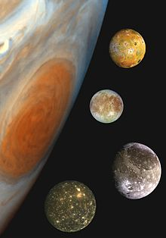](https://www.google.com/url?sa=i&url=https%3A%2F%2Ffr.wikipedia.org%2Fwiki%2FSatellites_galil%25C3%25A9ens&psig=AOvVaw2pFw4KlVg9pIoiF4fc0rjW&ust=1622562589453000&source=images&cd=vfe&ved=0CAIQjRxqFwoTCNDxyemi9PACFQAAAAAdAAAAABAD)