Archimede

Nom :archimede

[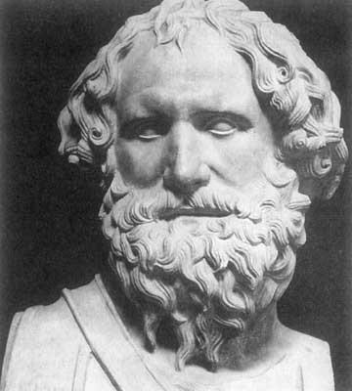](https://www.google.ca/url?sa=i&rct=j&q=&esrc=s&source=images&cd=&ved=2ahUKEwi-rPqyut3kAhXFc98KHQveADoQjRx6BAgBEAQ&url=https%3A%2F%2Fdemidieux.fandom.com%2Fwiki%2FArchim%25C3%25A8de&psig=AOvVaw0kVaQe6ZseN7nWaKEnh_Fr&ust=1569002086242369)

Nom complet : Archimedes of Syracuse

Periode de temps : 287 av. J.-C 212 av. J.-C

Nationalité :grec

[](http://www.google.ca/url?sa=i&rct=j&q=&esrc=s&source=images&cd=&cad=rja&uact=8&ved=&url=%2Furl%3Fsa%3Di%26rct%3Dj%26q%3D%26esrc%3Ds%26source%3Dimages%26cd%3D%26ved%3D%26url%3Dhttps%253A%252F%252Ffr.123rf.com%252Fphoto_19623319_drapeau-officiel-de-la-gr%2525C3%2525A8ce-nation.html%26psig%3DAOvVaw2tswjfVd27who0r1ykTdVk%26ust%3D1569002622199205&psig=AOvVaw2tswjfVd27who0r1ykTdVk&ust=1569002622199205)

Découvert :la balance

Ouvre :le codex d’archimede

[](http://www.google.ca/url?sa=i&rct=j&q=&esrc=s&source=images&cd=&ved=2ahUKEwinnOqBvt3kAhXBo1kKHcG7DaAQjRx6BAgBEAQ&url=http%3A%2F%2Fwww.cultura.com%2Fle-codex-d-archimede-9782709629355.html&psig=AOvVaw25SHfggo4tvbj6NaLrP1QH&ust=1569003054793298)