Dalton

Fait par Félix breau

nom John Dalton

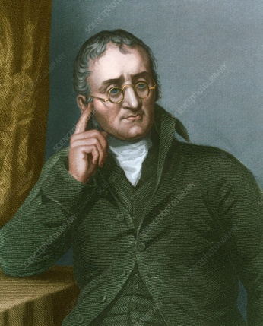

Nationalité [Royaume-Uni](https://www.google.com/search?safe=strict&biw=1440&bih=757&q=Eaglesfield&stick=H4sIAAAAAAAAAOPgE-LQz9U3SDaoMFfiArFMDcuzS4q0xLKTrfQLUvMLclKBVFFxfp5VUn5R3iJWbtfE9JzU4rTM1JwUAEkFsVM-AAAA&sa=X&ved=2ahUKEwilu66wksflAhUCpFkKHaXxCp4QmxMoATAeegQIDRAH&cshid=1572547239189578)

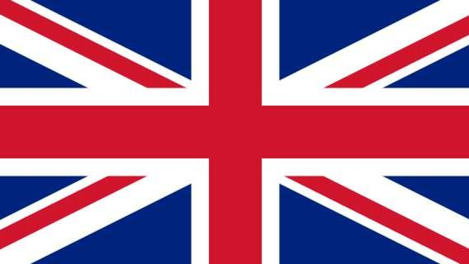

Decouvrte atomique

