Leeuwenhoek

Fait par Félix et Dylan

Nom complais : Antoni van Leeuwenhoek

[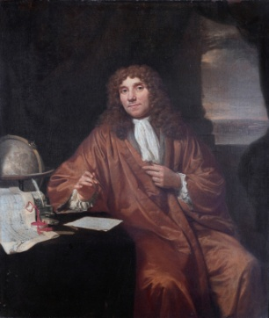](http://www.google.ca/url?sa=i&rct=j&q=&esrc=s&source=images&cd=&cad=rja&uact=8&ved=2ahUKEwjXtN3NjsnkAhVPLBoKHYUaDYUQjRx6BAgBEAQ&url=%2Furl%3Fsa%3Di%26rct%3Dj%26q%3D%26esrc%3Ds%26source%3Dimages%26cd%3D%26ved%3D2ahUKEwjHvYrLjsnkAhWMx4UKHfdpDU0QjRx6BAgBEAQ%26url%3Dhttps%253A%252F%252Ffr.wikipedia.org%252Fwiki%252FAntoni_van_Leeuwenhoek%26psig%3DAOvVaw1OUW5x8n80B3FoamDZ0VIH%26ust%3D1568303045782480&psig=AOvVaw1OUW5x8n80B3FoamDZ0VIH&ust=1568303045782480)

Image de lui

[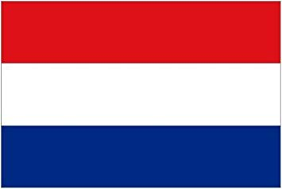](https://www.google.ca/url?sa=i&rct=j&q=&esrc=s&source=images&cd=&ved=2ahUKEwiFjcPujsnkAhUmtlkKHXGlAOQQjRx6BAgBEAQ&url=https%3A%2F%2Fwww.amazon.fr%2FDrapeau-Pays-Bas-Holland-53-91%2Fdp%2FB007F2I724&psig=AOvVaw2yuzIuOQMVa1TG-iv_ay_p&ust=1568303206129543)

Nation+drapeau néerlandais

Periode de temps 1632 1732

Decouverte microscope[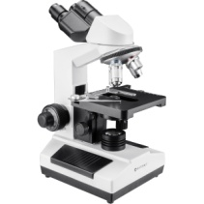](https://www.google.ca/url?sa=i&rct=j&q=&esrc=s&source=images&cd=&ved=2ahUKEwjItJjQj8nkAhUoy4UKHQ0KBocQjRx6BAgBEAQ&url=https%3A%2F%2Fwww.bhphotovideo.com%2Fc%2Fproduct%2F1344311-REG%2Fbarska_ay13074_binocular_compound_microscope.html&psig=AOvVaw1LPgRNxIVJcFqVPAIUB2Xo&ust=1568303409723213)

Image de sa découverte[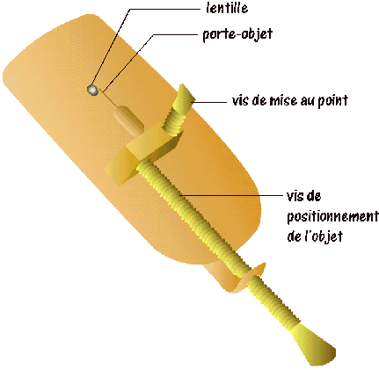](http://www.google.ca/url?sa=i&rct=j&q=&esrc=s&source=images&cd=&cad=rja&uact=8&ved=2ahUKEwjy44KakMnkAhVHwlkKHTfcAuEQjRx6BAgBEAQ&url=http%3A%2F%2Fwww.google.ca%2Furl%3Fsa%3Di%26rct%3Dj%26q%3D%26esrc%3Ds%26source%3Dimages%26cd%3D%26ved%3D%26url%3Dhttp%253A%252F%252Fwww4.ac-nancy-metz.fr%252Fsvt%252Fenseign%252Fsvt%252Fprogram%252Ffichacti%252Ffich2%252Fcellule%252Fmicrovl.htm%26psig%3DAOvVaw3b3hJU3PuXsOO1-kPWiF3j%26ust%3D1568303485452292&psig=AOvVaw3b3hJU3PuXsOO1-kPWiF3j&ust=1568303485452292)