Little figther

Fait par Jacob Laliberté

1: YOU WERE ALWAYS ALONE OUT ON THE SEA

2: YOU WERE A FIGHTER FOR PEACE-WITHOUT A WEAPON IN YOUR HAND

3: White Lion

4: Rainbow Warrior

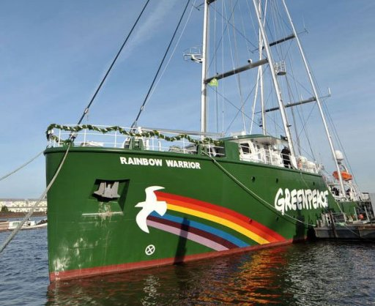

5: Green peace

6: Le bateau a exploser

7: Service secret

8: La France

9: Photograph tuée

10: Nouvelle-Zélande-Auckland

11: François Mitterand