Kazakhstan

[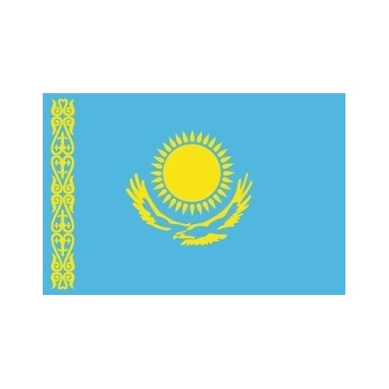](https://www.google.ca/url?sa=i&rct=j&q=&esrc=s&source=images&cd=&ved=2ahUKEwix1Y-M1YDlAhWrTd8KHYH6DYMQjRx6BAgBEAQ&url=https%3A%2F%2Fborney.com%2Fpays-du-monde%2F1165-drapeau-kazakhstan.html&psig=AOvVaw0lptVBbWSwgHiM1tysYETz&ust=1570211843150039)Drapeau :

[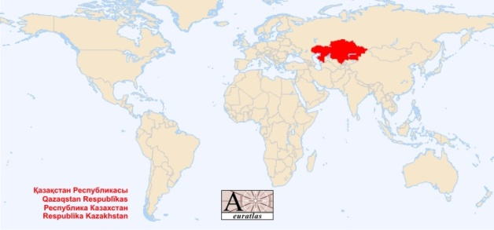](https://www.google.ca/url?sa=i&rct=j&q=&esrc=s&source=images&cd=&ved=2ahUKEwiu_I3A1YDlAhUhWN8KHc-aDioQjRx6BAgBEAQ&url=https%3A%2F%2Fworld.euratlas.net%2Fcountries%2Ffr_kazakstan.html&psig=AOvVaw0KJtSGuvgX0XgHaqsfvKBf&ust=1570211931859680)

Kazakhstan sur carte :

[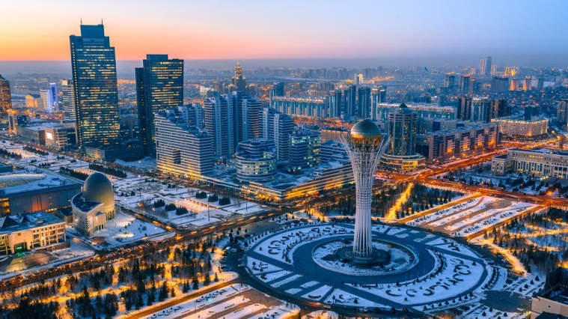](https://www.google.ca/url?sa=i&rct=j&q=&esrc=s&source=images&cd=&ved=2ahUKEwiXuKqG1oDlAhXmQ98KHSVICloQjRx6BAgBEAQ&url=https%3A%2F%2Flenergeek.com%2F2018%2F09%2F28%2Fkazakhstan-energies-renouvelables%2F&psig=AOvVaw1WsTjfIFkihUdkejdksewc&ust=1570212098488591)

Paysage :

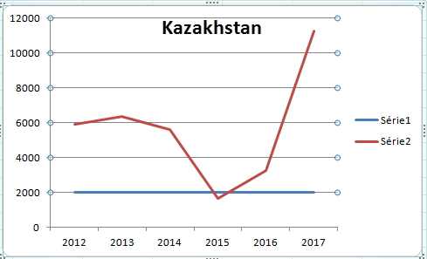

|  |  |
| --- | --- |
| Pays | Kazakhstan |
| Années | enfant non scolarisé |
| 2012 | 5929 |
| 2013 | 6371 |
| 2014 | 5624 |
| 2015 | 1671 |
| 2016 | 3263 |
| 2017 | 11270 |