**Mongolie**

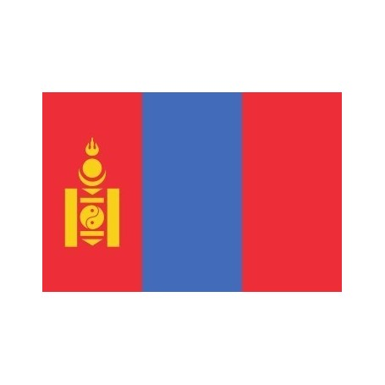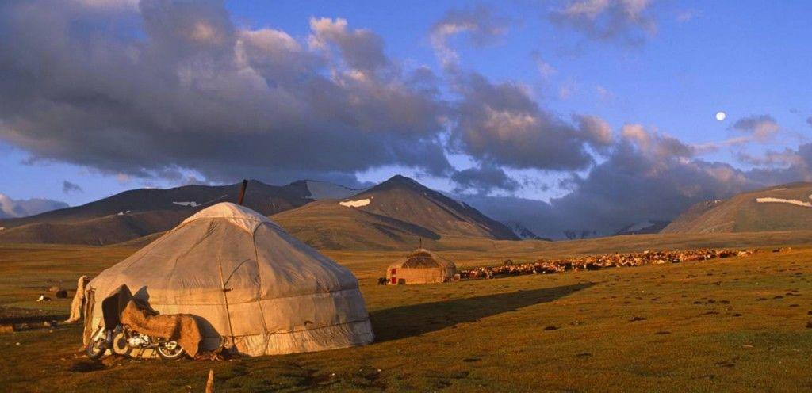

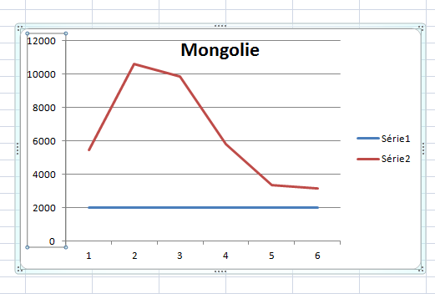

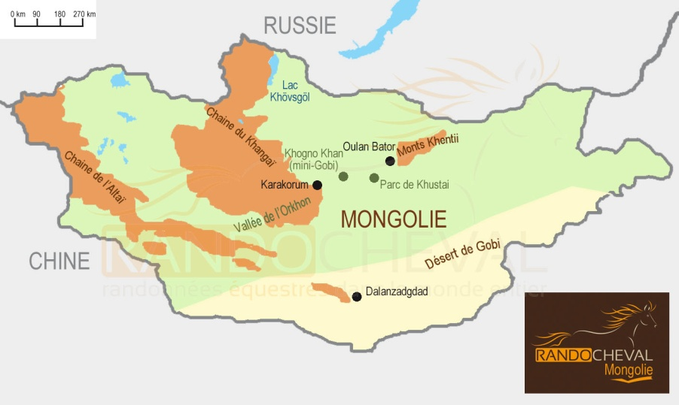

|  |  |
| --- | --- |
| Pays | Mongolie |
| Années | Enfants non scolarisés |
| 2012 | 5463 |
| 2013 | 10600 |
| 2014 | 9871 |
| 2015 | 5817 |
| 2016 | 3355 |
| 2017 | 3169 |