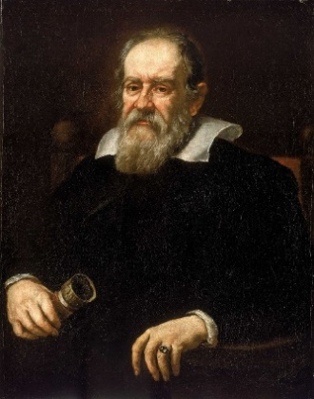Galilé

Nom: *Galileo Galilei*

Nationalité: Italien



Période de temps: 1564 - 1642

Découverte, oeuvre: [Ganymède](https://www.google.com/search?safe=strict&sa=X&bih=880&biw=1903&hl=fr&q=Ganym%C3%A8de+(lune)&stick=H4sIAAAAAAAAAOPgE-LQz9U3MDbJLlYCs9JMLZK1lLOTrfQTi0uK8vPycyvhrNQiq5TM4uT8stSi1JRFrALuiXmVuYdXpKQqaOSU5qVq7mBlBAA5KTofUQAAAA&ved=2ahUKEwixjb6rrtPwAhURZN8KHUPeAM0QmxMoATAnegQIJRAD), [Europe](https://www.google.com/search?safe=strict&sa=X&bih=880&biw=1903&hl=fr&q=Europe+(lune)&stick=H4sIAAAAAAAAAOPgE-LQz9U3MDbJLlYCs5LKDEy1lLOTrfQTi0uK8vPycyvhrNQiq5TM4uT8stSi1JRFrLyupUX5BakKGjmleamaO1gZAVMR7jJOAAAA&ved=2ahUKEwixjb6rrtPwAhURZN8KHUPeAM0QmxMoAjAnegQIJRAE), [Io](https://www.google.com/search?safe=strict&sa=X&bih=880&biw=1903&hl=fr&q=Io+(lune)&stick=H4sIAAAAAAAAAOPgE-LQz9U3MDbJLlbiBLFMDItTzLSUs5Ot9BOLS4ry8_JzK-Gs1CKrlMzi5Pyy1KLUlEWsnJ75Cho5pXmpmjtYGQF2TnU5SwAAAA&ved=2ahUKEwixjb6rrtPwAhURZN8KHUPeAM0QmxMoAzAnegQIJRAF), [Callisto](https://www.google.com/search?safe=strict&sa=X&bih=880&biw=1903&hl=fr&q=Callisto+(lune)&stick=H4sIAAAAAAAAAOPgE-LQz9U3MDbJLlYCs5JK4gu0lLOTrfQTi0uK8vPycyvhrNQiq5TM4uT8stSi1JRFrPzOiTk5mcUl-QoaOaV5qZo7WBkBF5L3wlAAAAA&ved=2ahUKEwixjb6rrtPwAhURZN8KHUPeAM0QmxMoBDAnegQIJRAG), [Anneaux de Saturne](https://www.google.com/search?safe=strict&sa=X&bih=880&biw=1903&hl=fr&q=Anneaux+de+Saturne&stick=H4sIAAAAAAAAAOPgE-LQz9U3MDbJLlbiBLPKjfKMtZSzk630E4tLivLz8nMr4azUIquUzOLk_LLUotSURaxCjnl5qYmlFQopqQrBiSWlRXmpO1gZAZ_koJhUAAAA&ved=2ahUKEwixjb6rrtPwAhURZN8KHUPeAM0QmxMoBTAnegQIJRAH), [lunette astronomique](https://fr.wikipedia.org/wiki/Lunette_astronomique) et le soleil au centre de l’univers