Little Fighter

Simon Quigley

1. WERE ALWAYS ALONE OUT ON THE SEE
2. FIGHTER FOR PEACE-WEAPON IN YOUR HAND
3. White Lion
4. Rainbow Warrior
5. [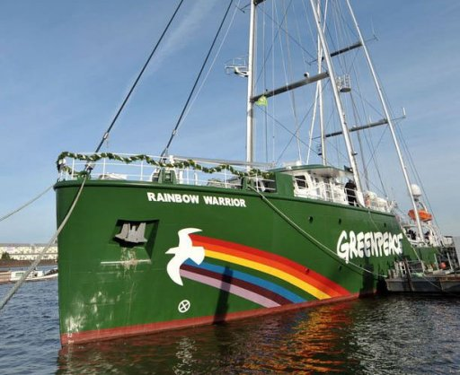](https://www.google.ca/url?sa=i&url=https://phys.org/news/2011-10-greenpeace-rainbow-warrior-iii.html&psig=AOvVaw2l80Sa3KY45bQzEIDGNCUh&ust=1605190747496000&source=images&cd=vfe&ved=0CAIQjRxqFwoTCNC41NbX-uwCFQAAAAAdAAAAABAD)Green Peace
6. Bateau explosion
7. Les service secret
8. France
9. La mort de Fernando
10. Auckland
11. Francois mitterent