[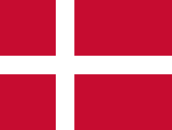](http://www.google.ca/url?sa=i&rct=j&q=&esrc=s&source=images&cd=&cad=rja&uact=8&ved=2ahUKEwi4lOvlk8flAhXnc98KHa5WBiMQjRx6BAgBEAQ&url=%2Furl%3Fsa%3Di%26rct%3Dj%26q%3D%26esrc%3Ds%26source%3Dimages%26cd%3D%26ved%3D%26url%3Dhttps%253A%252F%252Ffr.wikipedia.org%252Fwiki%252FDrapeau_du_Danemark%26psig%3DAOvVaw13xa1E8fMaUEJj4I5kLepO%26ust%3D1572633857721341&psig=AOvVaw13xa1E8fMaUEJj4I5kLepO&ust=1572633857721341)Bohr

Nom complet : niels borh

Nationalitée : danois

Drapeau :danois

[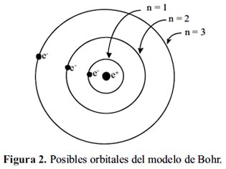](http://www.google.ca/url?sa=i&rct=j&q=&esrc=s&source=images&cd=&ved=2ahUKEwi408eDlMflAhWTNX0KHVF8CpIQjRx6BAgBEAQ&url=http%3A%2F%2Fwww.scielo.org.pe%2Fscielo.php%3Fscript%3Dsci_arttext%26pid%3DS1810-634X2013000200011&psig=AOvVaw381lbhSGG73qEzleIHfMyY&ust=1572633918088938)[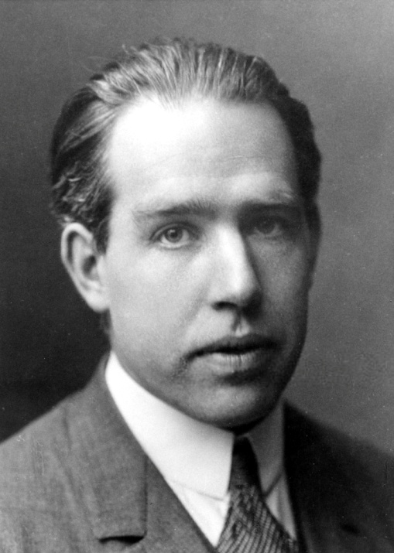](https://www.google.ca/url?sa=i&rct=j&q=&esrc=s&source=images&cd=&ved=2ahUKEwidkszXk8flAhWFTN8KHR5VCIQQjRx6BAgBEAQ&url=https%3A%2F%2Ffr.wikipedia.org%2Fwiki%2FNiels_Bohr&psig=AOvVaw2Sa37zPHA-gSbuRMYcy9QC&ust=1572633827876310)Decouverte :orbitales