[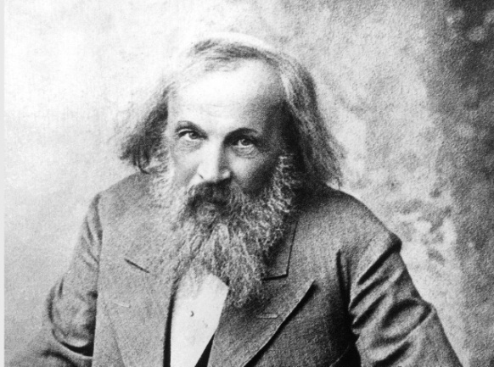](https://www.courrierinternational.com/article/chimie-le-systeme-mendeleiev-fete-ses-150-ans)Mendeliev

Nom complet :dimitri ivanovitch

Nationalité : russe

Drapau :russie

Decouverte : tableau periodique

[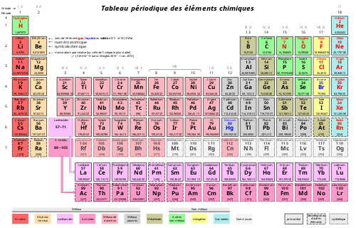](http://www.google.ca/url?sa=i&rct=j&q=&esrc=s&source=images&cd=&cad=rja&uact=8&ved=2ahUKEwjKzt2bkMflAhWsV98KHZBGDE8QjRx6BAgBEAQ&url=%2Furl%3Fsa%3Di%26rct%3Dj%26q%3D%26esrc%3Ds%26source%3Dimages%26cd%3D%26ved%3D%26url%3Dhttps%253A%252F%252Ffr.wikipedia.org%252Fwiki%252FTableau_p%2525C3%2525A9riodique_des_%2525C3%2525A9l%2525C3%2525A9ments%26psig%3DAOvVaw3n7q0RFKub5CfQKZBuzdQk%26ust%3D1572632893139200&psig=AOvVaw3n7q0RFKub5CfQKZBuzdQk&ust=1572632893139200)[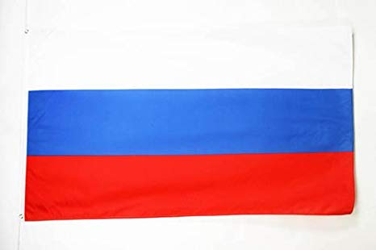](http://www.google.ca/url?sa=i&rct=j&q=&esrc=s&source=images&cd=&cad=rja&uact=8&ved=2ahUKEwjWxJaGkMflAhWOtlkKHbzwAmMQjRx6BAgBEAQ&url=%2Furl%3Fsa%3Di%26rct%3Dj%26q%3D%26esrc%3Ds%26source%3Dimages%26cd%3D%26ved%3D%26url%3Dhttps%253A%252F%252Fwww.amazon.fr%252FDRAPEAU-RUSSIE-90x60cm-RUSSE-DRAPEAUX%252Fdp%252FB00IEKS5FK%26psig%3DAOvVaw2D9sCAIvHTIzctsKO5ipF5%26ust%3D1572632786599894&psig=AOvVaw2D9sCAIvHTIzctsKO5ipF5&ust=1572632786599894)Periode de temps :1883-1907