[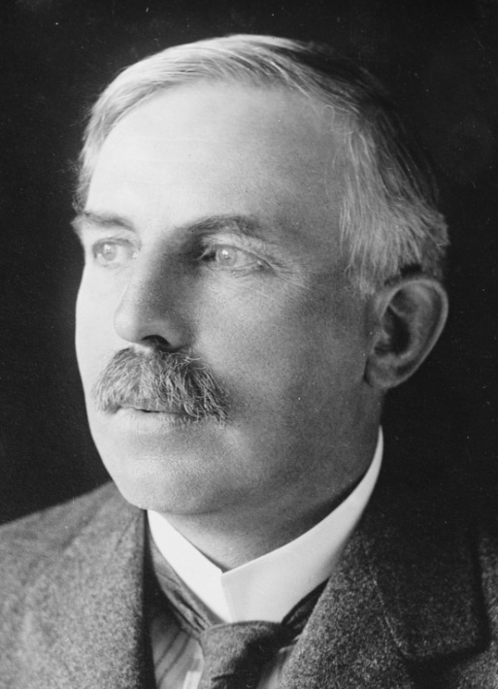](https://www.google.ca/url?sa=i&rct=j&q=&esrc=s&source=images&cd=&ved=2ahUKEwin27T2kMflAhWLtlkKHZ7EBOQQjRx6BAgBEAQ&url=https%3A%2F%2Ffr.wikipedia.org%2Fwiki%2FErnest_Rutherford&psig=AOvVaw2jnC7RGeUo876GnWy2-niD&ust=1572633087368337)Rutherford

Nom complet :Ernest Ruterford

Nationalité :Nouvelle-zélande

Drapeau :nouvelle-zéland

Decouverte :noyau+

[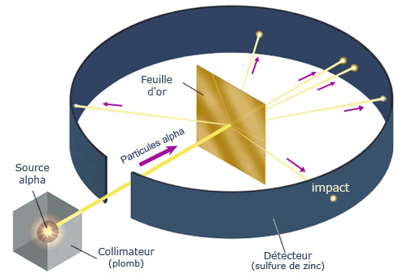](http://www.google.ca/url?sa=i&rct=j&q=&esrc=s&source=images&cd=&cad=rja&uact=8&ved=2ahUKEwi95p20jcflAhXng-AKHZiIDfEQjRx6BAgBEAQ&url=/url?sa=i&rct=j&q=&esrc=s&source=images&cd=&ved=&url=https%3A%2F%2Fmodeleatome.wordpress.com%2Fle-modele-de-rutherford%2F&psig=AOvVaw2zFp1uZwkDSmOl38vUXb7S&ust=1572632143358565&psig=AOvVaw2zFp1uZwkDSmOl38vUXb7S&ust=1572632143358565) Periode de temps :1871-1937[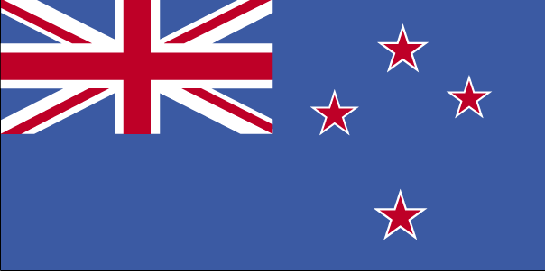](http://www.google.ca/url?sa=i&rct=j&q=&esrc=s&source=images&cd=&cad=rja&uact=8&ved=2ahUKEwix1_7kjMflAhVupVkKHXB5BvIQjRx6BAgBEAQ&url=http://www.cosmovisions.com/$NouvelleZelande.htm&psig=AOvVaw0iWNc9eRr5A6Rl_0_8iMrk&ust=1572631962333762)