[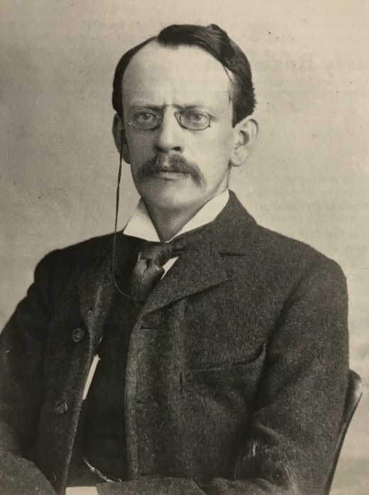](https://www.google.com/url?sa=i&rct=j&q=&esrc=s&source=images&cd=&ved=2ahUKEwixuZ_wiMflAhXs01kKHWF3AKkQjRx6BAgBEAQ&url=https://owlcation.com/humanities/JJ-Thomson-and-the-Discovery-of-the-Electron&psig=AOvVaw21eqLI4qGN1ixKgxEtJc6j&ust=1572630924155151)Thomson

Fait par thomas lamontagne

Nom complet : joseph jonh thomson

[](https://www.google.com/url?sa=i&rct=j&q=&esrc=s&source=images&cd=&ved=2ahUKEwip79PjjcflAhWBq1kKHdhLCBEQjRx6BAgBEAQ&url=https%3A%2F%2Fborney.com%2Fpays-d-europe%2F1228-drapeau-royaume-uni.html&psig=AOvVaw2_uG_KDdeIXMa2VmEzjUTa&ust=1572632242940579)Decouverte :charge atomique

Nationalité : anglophone

Periode de tems :1856-1940

Drapeau :anglais

[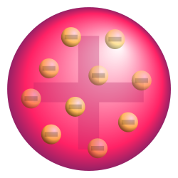](http://www.google.com/url?sa=i&rct=j&q=&esrc=s&source=images&cd=&cad=rja&uact=8&ved=2ahUKEwjCgZH7icflAhVsxFkKHeTGBioQjRx6BAgBEAQ&url=/url?sa=i&rct=j&q=&esrc=s&source=images&cd=&ved=&url=https%3A%2F%2Ffr.wikipedia.org%2Fwiki%2FMod%25C3%25A8le_atomique_de_Thomson&psig=AOvVaw02yiA6Sa7MVs_psSp4LdlB&ust=1572631218332064&psig=AOvVaw02yiA6Sa7MVs_psSp4LdlB&ust=1572631218332064)