[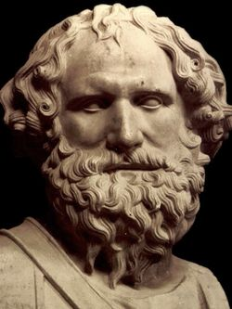](https://www.google.ca/url?sa=i&rct=j&q=&esrc=s&source=images&cd=&ved=2ahUKEwi_7rLsud3kAhVEqlkKHf02D5YQjRx6BAgBEAQ&url=https%3A%2F%2Fanniversaire-celebrite.com%2Farchimede-c6443.html&psig=AOvVaw3z8rsYWG1wk8NrQTmtGtUF&ust=1569001928669697)Fait par thomas lamontagne

Nom complet :Archimede de syracuse

[](https://www.google.ca/url?sa=i&rct=j&q=&esrc=s&source=images&cd=&cad=rja&uact=8&ved=2ahUKEwi15Nb0ut3kAhWQdd8KHQb1AtwQjRx6BAgBEAQ&url=https%3A%2F%2Fwww.amazon.fr%2FPROMOTION-Drapeau-Gr%25C3%25A8ce-Uniquement-SUPPORTER%2Fdp%2FB003DKGJR2&psig=AOvVaw3GMv_bKloGsWXvAxlu4Dsq&ust=1569002158785271)Periode de temps : 287 av j-c -- 212av j-c

Nationalité :grec

Decouverte :vis d’archimede griffe d’archimede et architonner

[](http://www.google.ca/url?sa=i&rct=j&q=&esrc=s&source=images&cd=&ved=2ahUKEwiY06iQvd3kAhUmmeAKHTvnCO0QjRx6BAgBEAQ&url=http%3A%2F%2Fwww.cultura.com%2Fle-codex-d-archimede-9782709629355.html&psig=AOvVaw0-GVoCTWNEznTdp8pJUccA&ust=1569002797588558)Son live : le codex d’archimede