[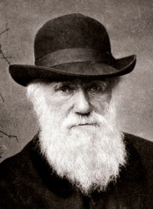](https://www.google.ca/url?sa=i&rct=j&q=&esrc=s&source=images&cd=&ved=2ahUKEwjV8ay2_NzkAhUTnZ4KHXuyAV8QjRx6BAgBEAQ&url=https://fr.wikipedia.org/wiki/Charles_Darwin&psig=AOvVaw1ppf6SEynbSVi8PY3JZMxz&ust=1568985444993597)Nom :Charle Darwin

Periode de temps :1809-1882

[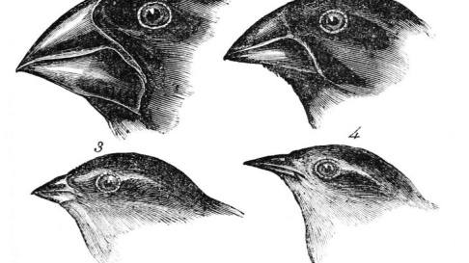](https://www.google.ca/url?sa=i&rct=j&q=&esrc=s&source=images&cd=&ved=2ahUKEwih2NGK_dzkAhWIJzQIHTPwDZAQjRx6BAgBEAQ&url=https%3A%2F%2Fwww.earth.com%2Fearthpedia-articles%2Fwhat-is-charles-darwins-theory-of-evolution%2F&psig=AOvVaw1JWFW6CrWVm-a4oCLqpvIC&ust=1568985608622540)Decouverte :Évolution

[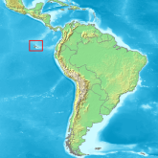](https://www.google.ca/url?sa=i&rct=j&q=&esrc=s&source=images&cd=&ved=2ahUKEwj1juLF_dzkAhVLsp4KHcgIBTgQjRx6BAgBEAQ&url=https%3A%2F%2Fet.wikipedia.org%2Fwiki%2FGal%25C3%25A1pagose_saared&psig=AOvVaw1K5UmGLAt5zvHGMLeu204j&ust=1568985731258875)Preuve :fossile

[](https://www.google.ca/url?sa=i&rct=j&q=&esrc=s&source=images&cd=&ved=2ahUKEwi11IyH_tzkAhWE4J4KHYysCZAQjRx6BAgBEAQ&url=https%3A%2F%2Fborney.com%2Fpays-d-europe%2F1228-drapeau-royaume-uni.html&psig=AOvVaw3lynUF3Bk95pLqZtcrZZUd&ust=1568985887469931)Endroit :Galapagose

Nationalité :britanique

[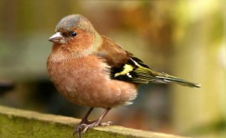](https://www.google.ca/url?sa=i&rct=j&q=&esrc=s&source=images&cd=&ved=2ahUKEwjP8N-0_tzkAhUXsp4KHUC3DI0QjRx6BAgBEAQ&url=https%3A%2F%2Fjardinage.lemonde.fr%2Fdossier-1453-pinson.html&psig=AOvVaw2wgH6mlgHaW4gZsaiWj0XF&ust=1568985980917370)

Animale :pinson

[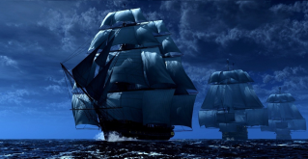](https://www.google.ca/url?sa=i&rct=j&q=&esrc=s&source=images&cd=&ved=2ahUKEwj984zO_9zkAhXTs54KHefoC4sQjRx6BAgBEAQ&url=https%3A%2F%2Fnoticeoftrink.wordpress.com%2F2014%2F04%2F14%2Fla-difference-entre-bateau-et-un-navire%2F&psig=AOvVaw2cJ-4LU57cHGe31ftfQUyq&ust=1568986302330126)

Transport :beugel

Conflit :église

Caricature:gorille