Little Fighter

Fait par Vincent Cliche

1# AND YOU WERE ALWAYS ALONE OUT ON THE SEA

2#YOU WERE A FIGHTER FOR PEACE

3# White Lion

4# Rainbow Warrior

5# Organisation pour le bateau Warrior (green peace)

6# explosion du bateau

7# Service secret

8# L France

9# La mort de Fernando Pereira

10# Aucklan

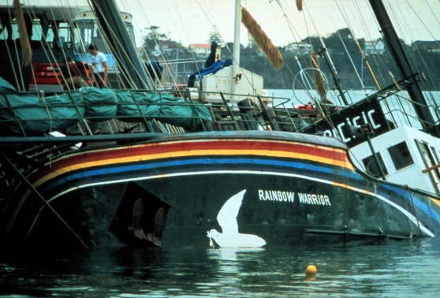11# François Mitterant