Starcraft

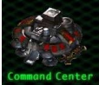
Base

Labo

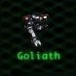
Goliath

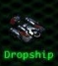
Droppship

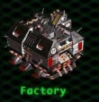
Usine

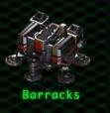
Barracks

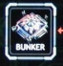
Bunker

Armory
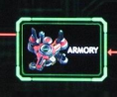

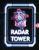
radartowel

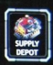
supply depot

