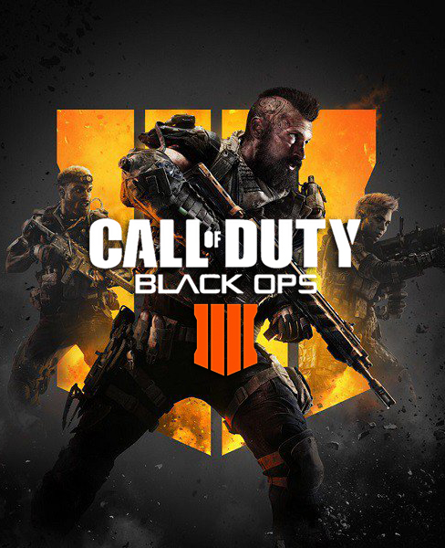
Hey guys, today I will present my favorite game. My favorite game is Call of duty Black ops 4. I think this game is not for everybody because the goal of this game is that you must kill a lot of people to win the game and is not everybody may like that and like a blood. I find Cod very interesting because I have a lot of mode like mode zombie, multiplayers etc. I could choose the zombie mode, but I prefer the multiplayer mode because in this mode I have a lot of possibilities like a gun game, limit of time and lot of other mode. And you may choose a lot of skin. The strategy for succeed is to choose very good weapon and to kill the people and upgrade your level and create the classes of gun do your preferred and deblocked lot of mode. I think the graffiti at the game could be ameliorated because the house at is game not very realist. My opinion is the on the creator of the game I can add a new gun and a new map and ad a car to the game because I like riding with the cars and crushing the people with my cars. I think the game is really like about the people play this game because he may have a lot of Reale people in your game. I hope that my text can help you and you download the game and play the game. Goodbye guys.

Jordan Drouin

