archimède[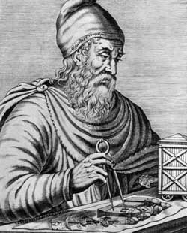](https://sites.google.com/site/caesarnonsupragrammaticos/home/iii-emes/iv-les-romains-et-la-science/archimde)

nationalité :grèce[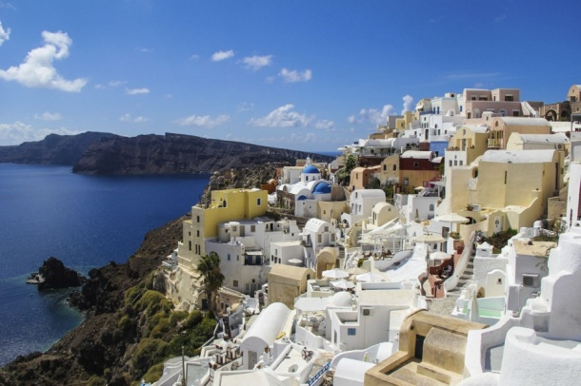](https://www.google.ca/url?sa=i&url=https%3A%2F%2Fwww.lapresse.ca%2Fvoyage%2Fdestinations%2Feurope%2Fgrece%2F201408%2F13%2F01-4791419-la-grece-dile-en-ile.php&psig=AOvVaw0O743Xd58Ndprc0HtZd1Id&ust=1605205623488000&source=images&cd=vfe&ved=0CAIQjRxqFwoTCPizspWP--wCFQAAAAAdAAAAABAD)[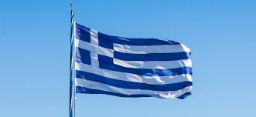](https://www.google.ca/url?sa=i&url=https%3A%2F%2Fwww.ribambel.com%2Farticle%2Fque-signifie-le-drapeau-de-la-grece%2F2131&psig=AOvVaw1BaMP_ApfSk-yG1gQoi7mS&ust=1605205952119000&source=images&cd=vfe&ved=0CAIQjRxqFwoTCPiH2KaQ--wCFQAAAAAdAAAAABAI)

période de temps :288 A.-J

découverte d’archimède :Poussée[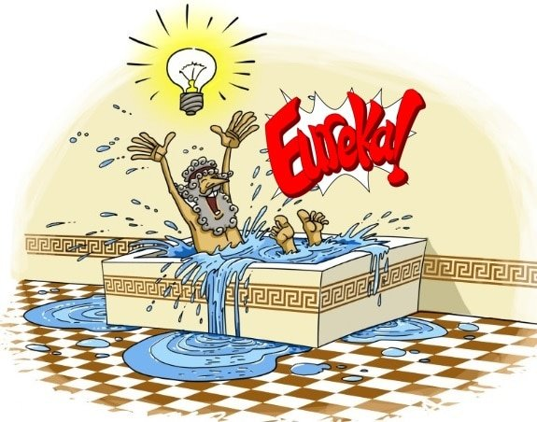](https://www.google.ca/url?sa=i&url=https%3A%2F%2Fwww.genie-inc.com%2F7-grands-moments-eureka-de-scientifiques-ingenieurs%2F&psig=AOvVaw2w5dkBFcPiudakkpj9iQx5&ust=1605206057479000&source=images&cd=vfe&ved=0CAIQjRxqFwoTCPj6y-OQ--wCFQAAAAAdAAAAABAD)