1. Base spatial🡺comand center
2. Entrepot🡺supply depot 10 x
3. Communication🡺tourelle🡪turnet
4. Ressource gaz 🡺raffinerie 🡪raffinery
5. Transport au sol🡺tank,goliath
6. Transport plus haut🡺valkyrie,battlecruiser
7. Batisses de soldat🡺barrackh
8. Usine de fabrication🡺factory
9. 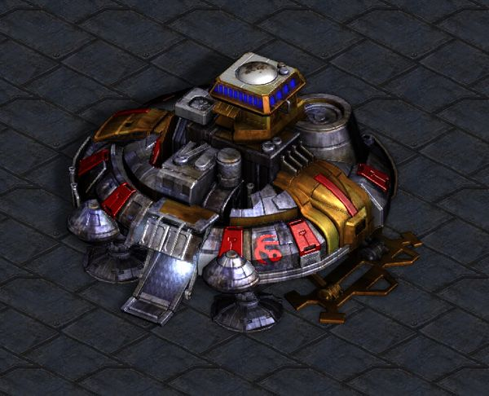Zone de lancement🡺start point j.Ingénieur🡺engineering back



