4 cercles
De Nathan Gosselin

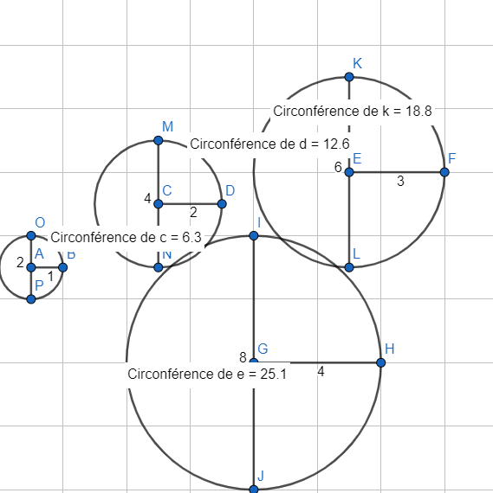

cercles | rayon | diametre | circonference | c/d
1 | 1 | 2 | 6.3 | 3.15
2 | 2 | 4 | 12.6 | 3.15
3 | 3 | 6 | 18.8 | 3.1333333
4 | 4 | 8 | 25.1 | 3.1375

