starcraft

1. 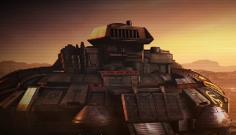Base spatiale 🡺 command center
2. 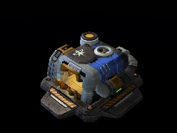Entrepôt 🡺 supply depot 10x
3. Communication 🡺 tourelle > turret
4. Ressource gaz 🡺 raffinerie > raffinery
5. 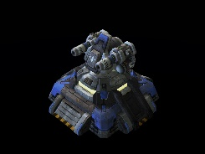Transport au sol 🡺 tank, goliath
6. 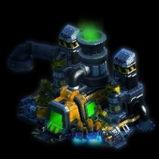Transport plus haut 🡺 valkyrie, battlecruiser
7. Batisses de soldat 🡺 barrak
8. 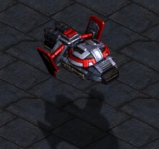Usine de fabrication 🡺 factory
9. 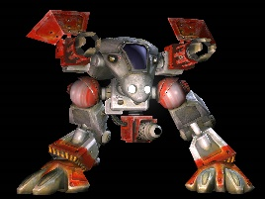Zone de lancement🡺 starport
10. Ingenieur 🡺 engineering bay

