Pays

Cabo verde



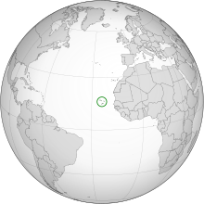

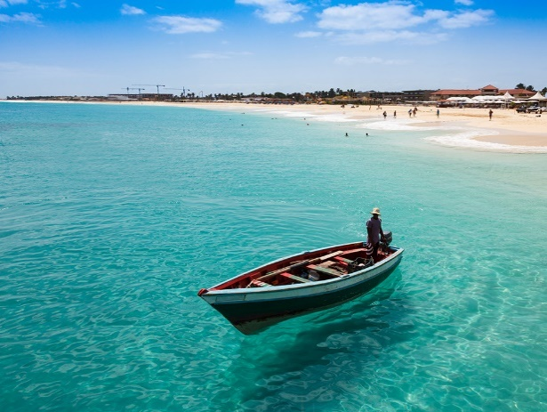

|  |  |
| --- | --- |
| 2012 | 8748 |
| 2013 | 8906 |
| 2014 | 8730 |
| 2015 | 8646 |
| 2016 | 9041 |
| 2017 | 9073 |

