 | Check Point Threat Extraction secured this document |  | Get Original

Nobel
Alfred nobel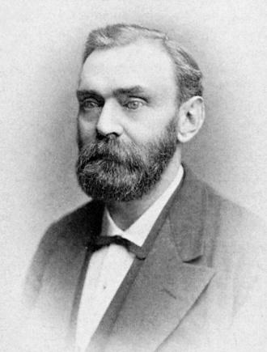

1833-1893
Suedois 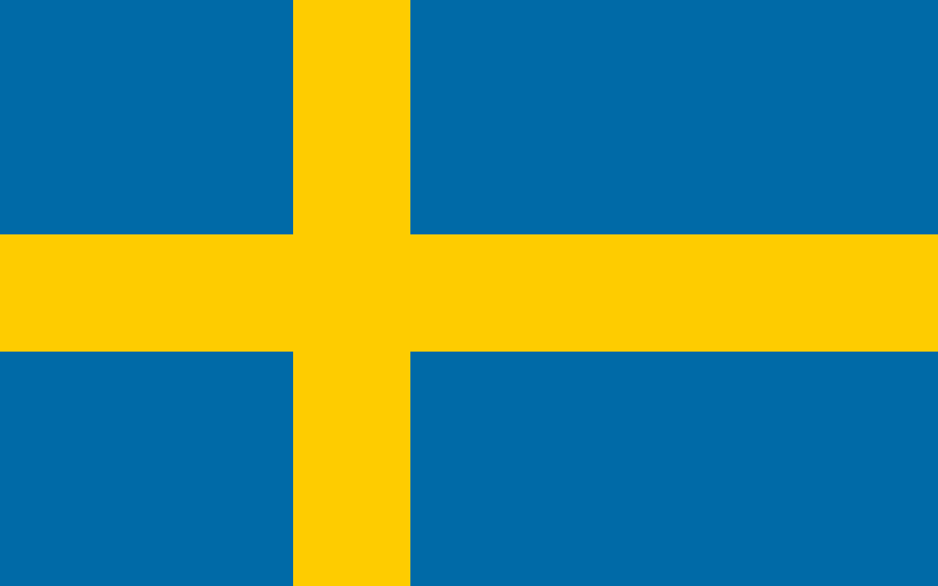
dynamite