Starcraft fait pas Alex Vachon
A. base spatiale ==> command center
B. entrepôt ==> supply depot 10 x
C. communication ==> tourelle ­­> turret
D. ressource gaz ==> raffinerie­­> raffinery
E. transport au sol ==> tank, goliath,
F. transport plus haut ==> valkyrie, battlecruiser,
G. bâtisses de soldats ==> barrack
H. usine de fabrication ==> factory
I. zone de lancement ==> starport
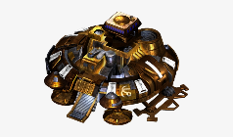
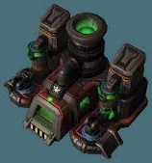
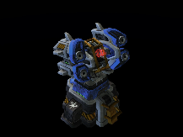
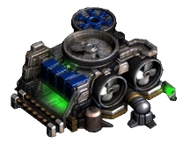
J. ingénieur ==>engineering bay
