Cercle par Alexy Lessard

MSI 1

20 avril 2023

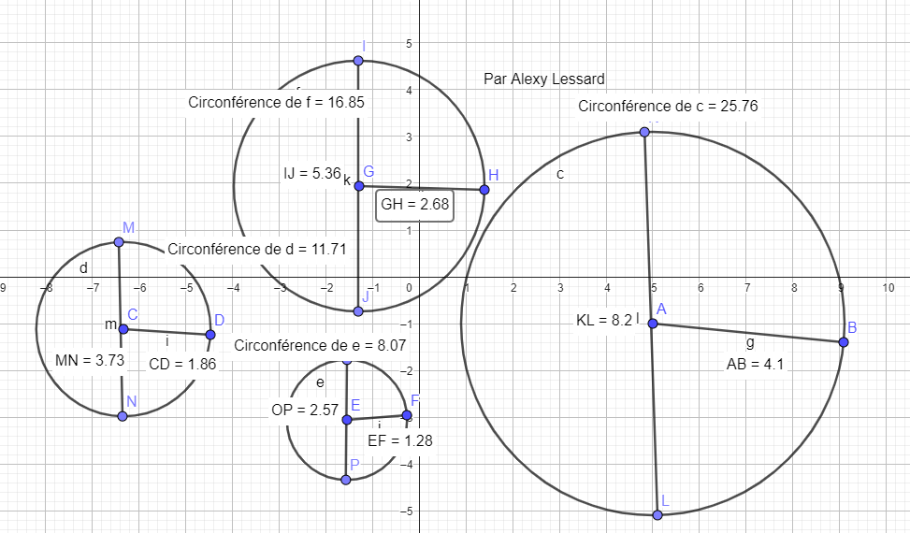

|  |  |  |  |  |
| --- | --- | --- | --- | --- |
| Cercles | Rayon | Diamètre | Circonférence | C / D |
| 1 | 1.28 | 2.57 | 8.07 | 3.14 |
| 2 | 1.86 | 3.73 | 11.71 | 3.14 |
| 3 | 2.68 | 5.36 | 16.85 | 3.14 |
| 4 | 4.10 | 8.20 | 25.76 | 3.14 |