Cercle par Charle-Antoine Giroux

MSI 1

2023-04-20

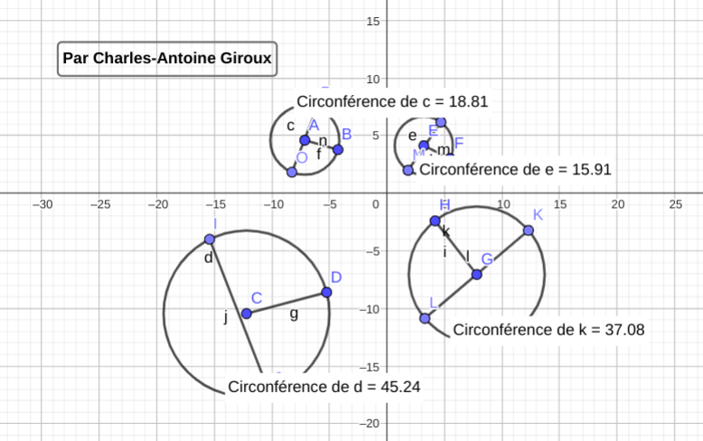

|  |  |  |  |  |
| --- | --- | --- | --- | --- |
| Cercles | Rayon | Diamètre | Circonférence | C/D |
| 1 | 14.34 | 14.34 | 45.24 | 3.833 |
| 2 | 11.8 | 11.8 | 37.08 | 3.142 |
| 3 | 2.38 | 2.38 | 15.91 | 6.684 |
| 4 | 0 | 0 | 18.81 | 0 |