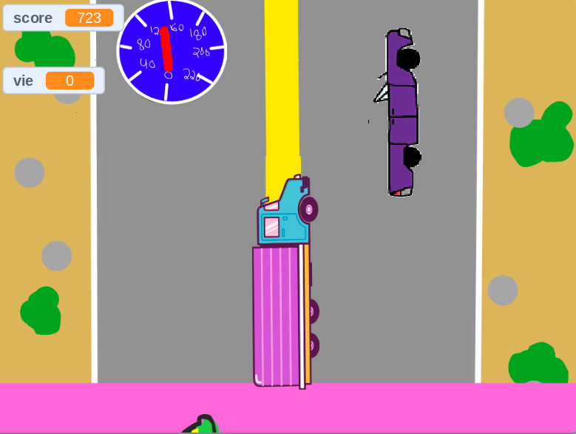

Car crash.Elo
Designed Around You. Make it happen.
Démo

