Pays

Iran

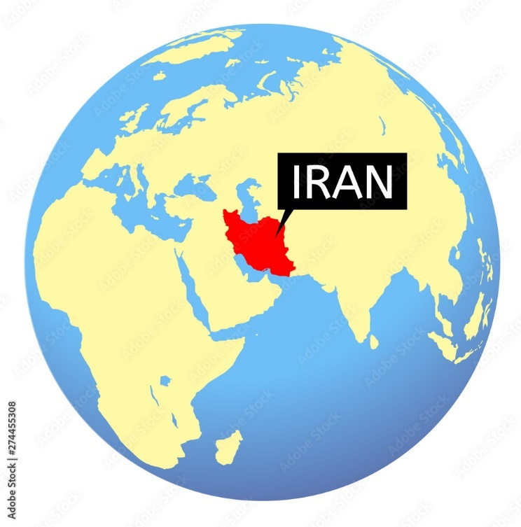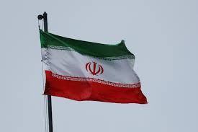

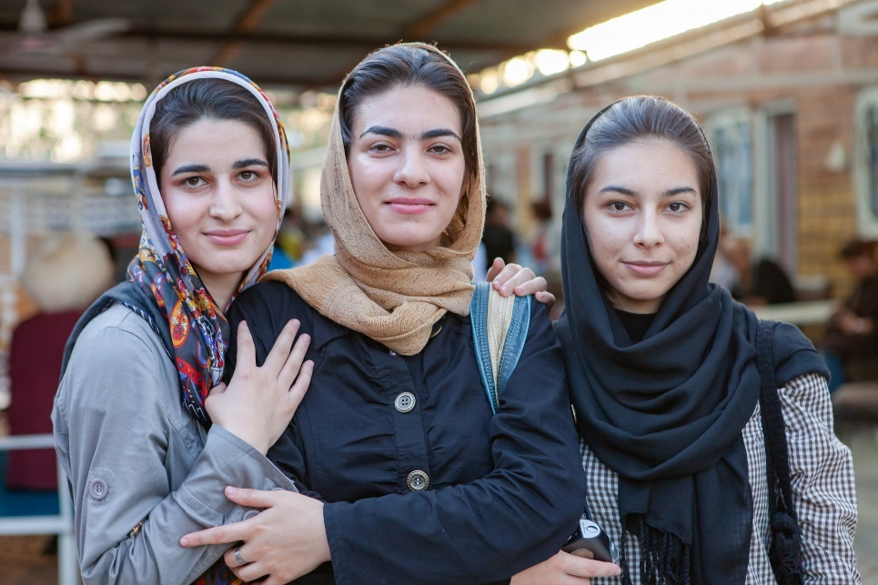

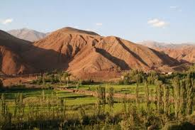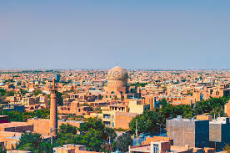

|  |  |  |  |  |  |  |  |  |  |  |  |  |  |  |  |  |
| --- | --- | --- | --- | --- | --- | --- | --- | --- | --- | --- | --- | --- | --- | --- | --- | --- |
| |  |  | | --- | --- | | Élèves n'ayant pas accès à l'école ( Iran ) | | | Années | Nombre | | 2012 | 19 227 | | 2013 | 90 884 | | 2014 | 30 869 | | 2015 | 41 355 | | 2016 | 63 106 | | 2017 | 101 141 | |

