|  |  |  |  |
| --- | --- | --- | --- |
|  | Check Point Threat Extraction secured this document |  | [Get Original](http://10.54.10.10/UserCheck/PortalMain?IID=%7b6908D6DA-7423-C571-4140-7EF6FBFC31DC%7d&origUrl=) |

Projet starcraft

Par Loïk

1. Base spatiale 🡺 command center 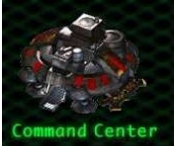
2. Entrepôt 🡺 supply depot 10x
3. Communication 🡺 tourelle🡪turret
4. Ressource gas 🡺 raffinerie 🡪 raffinery
5. Transport au sol 🡺 tank, goliath